Overview: This Research Project serves as your opportunity to delve deeper into the subject matter that you have learned throughout the year. There are a plethora of Psychology topics from which to choose. Obviously, pick a topic of high interest to you. Do not choose something just because it appears easy or because your friends want to research it. After your research is complete, you will formally present your findings to the class.
- This project is worth 100 points.
- Projects will be presented between ___________and ___________dates.
Absolutely no projects will be accepted after ___________.
- You may choose any topic you wish. However, you must have the topic approved by me by no later than ___________.
- This project may be used in conjunction with another class (e.g. AP Statistics). However, you must get approval from all teachers involved.
- You may work alone or with a small group (maximum of 4 students). Please note I expect more work from larger groups, and the project will be graded accordingly.
- All projects (regardless of approach) must be typed. I will NOT accept handwritten projects.
- You are highly encouraged to incorporate various mediums (e.g. a video, PowerPoint, poster) to enhance your presentation. However, remember that you must turn in a detailed, written study. Please see me for possible formats. Also, PLEASE alert me to your audio/visual needs well in advance.
- When thinking of how you will present, please consider that iPads will (most likely) have been returned to the district by the presentation dates.
- You will have a 20 minute window in which to present. Recommended agenda:
Set-up: 2 minutes | Presentation: 15 minutes | Q&A: 3 minutes
- Your presentation must be engaging! If I’m bored, I will dock points. Consider including an awe inspiring video, a riveting skit, or audience participation - practice experiment, demonstration, recreation, or an in-class survey. Be sure to rehearse!
- All projects must include evidence (pictures, video, completed surveys, witness statements, etc.) that prove you performed the project.
- As always, neatness, organization, clarity, and overall professionalism will play major factors in determining your grade
- You have four Project Approaches from which to choose. Each approach is listed below and then later described in detail:
  - Mental Disorders Research, CASE STUDY and Presentation
  - Psychology EXPERIMENT and Presentation
  - Author a Psychology MAGAZINE and Presentation
  - CREATE your own project and Presentation (with teacher approval)
I. Mental Disorders Research, CASE STUDY and Presentation: Research a disorder (using the DSM-V TR and other sources), perform a case study (including appropriate interviews), and create a presentation for the class. Your report and presentation should emphasize links between relevant research and the case study conducted. Your project must include the following:
- DSM-V TR classification (diagnostic criteria) of the specific disorder
  - Symptoms and/or recognizable behaviors
  - Prognosis
  - Subtypes of the category of the disorder
- Prevalence Statistics: who does the disease affect? Gender? Age groups? Other?
- Etiology (Theories of Development): what are the different theories (biological / psychological / social) as to why people develop the disorder? Nature of the disorder / familial patterns of individuals diagnosed with the disorder.
- Detailed Case Study(s) of the Disorder:
  - Cases are stories with a message. They are not simply narratives for entertainment. They are stories to educate. Your ultimate goal is to move beyond the typical report and demonstrate your ability to analyze, interpret and critically evaluate your assessment of a single client in light of relevant psychological theory and research.
  - One or more case studies should be performed. You may wish to compare and contrast your case study(s) with additional studies that you have researched.
  - You are highly encouraged to interview actual patients with the disorder, their therapists, and anyone else who works, lives, or interacts with the patients. Prepare a questionnaire in advance. I must approve the questionnaire before usage. Please submit the completed questionnaire(s) with your final product.
  - A short video could enhance your presentation. This video may be dramatized, however, it should be based on actual facts and should be professional. If you record a patient, be sure that you obtain proper consent.
- Treatment Options for the Disorder. Specify which therapies would be most and least effective, and why.
  - Therapeutic: explicitly explain how each major therapy (psychoanalytic, behavioral, cognitive, humanistic) may be used to aid the patient.
  - Pharmaceutical: biological / drug therapy
  - Social support: what public assistance, social support groups, etc. are available locally?
  - Current research: what research is currently being done that could provide additional help in the future?
- Popular Culture: famous people diagnosed with the disorder, mentioned in movies, books, slang, etc.
- An Annotated APA Works Cited of all sources used by all group members.
Check out www.mentalhealth.com
II. Psychology EXPERIMENT and Presentation: Design an original experiment or partial-replication of an experiment relevant to a Psychological Concept that we have studied. You may “propose” a project from any area of psychology. Correlational or observational studies are acceptable but studies with at least one independent (manipulated) variable are encouraged.
Your project must include the following:
- Title page: use a catchy, all encompassing title.
- Abstract: a brief overview of your study. The abstract begins with a statement of the problem that is being investigated. It should establish a context for the project by reviewing related work in the field. It provides a brief description of the topic, the method, and the findings. A quick review of the abstract will allow the reader to determine whether the full article will be of interest. Also, the abstract provides a framework for understanding the rest of the article. The abstract ends with a statement of hypothesis.
- Method: details exactly how you (the researcher) conducted the study and who served as participants. All the information necessary to repeat (replicate) the study appears here. Includes information about apparatus (physical equipment) or instrumentation (e.g. survey) that was used for both the independent and dependent variables (or predictor and criterion variables, if a correlational study). The complete procedure used to administer the independent variable, control extraneous variables, and measure the dependent variable is described in this section. For details, see steps 1-6 on the following page.
- Results: states the findings, but does not explain what they mean. This section includes raw data and statistics. For example, if a correlational study is done, you would write something such as “A Pearson correlational analysis was conducted to determine the strength and direction of the correlation between anxiety and depression…” For details, see step 7 on the following page.
- Discussion: interpretation of the results (explanation of the data without the statistical details.) Describes what actually occurred and whether or not the findings support the original hypotheses. Explanations should tie back to the literature that was presented in the Abstract. In addition, this section should include logical ways to extend the research. For details, see step 8 on the following page.
- References: works cited in the article using APA format.
- Acknowledgements (optional): a page thanking everyone who helped with the process of designing, carrying out, and writing up the study.
- Appendices (optional): additional information (e.g. the actual survey used).

You must incorporate the Scientific Method in your experiment. Follow these simple steps:
- Identify a topic. Think of a psychological question that you would like to know the answer. Select one psychological principle that you can test in a safe, non-invasive, ethically sound manner. Ensure that referenced materials used are empirically based. Consider viewing Psychological journals (many are on ProQuest.), or speaking with / emailing local College / University faculty. Sample topic titles:
  - A Look at Youth in Trouble: Using Simple Ethics to Detect Potentially Troubled Teens
  - Speed and Cell Phones: Are Male or Female Brains Better Suited for the Task?
  - Effects of Specific Motivational Strategies in Conjunction With Locus of Control on Performance Improvement
  - Generation Z: Attitudes and Perceptions Toward the Aging Process
- Formulate your hypothesis: a testable prediction of a relationship between variables.
For example:
  - Q: “What is the relationship between eating breakfast and academic performance?”
  - Hypothesis 1: “Students who eat breakfast will have higher GPAs than students who do not eat breakfast.”
  - Hypothesis 2: “Students who eat protein for breakfast will have higher GPAs than students who do not eat protein for breakfast.”
- Identify research participants: participants may be human or nonhuman. In either case, be ethical! Parental permission must be obtained to experiment on children.
- Design and procedure: determine your independent variable(s), dependent variable(s), confounding variable(s), experimental group(s), control group(s), and random assignment(s). If a study is designed with more than one condition (e.g. treatment and control), randomly assigning participants to different groups strengthens the study. The procedure for conducting the project should be carefully documented (e.g. note conditions, location, etc.)
- Independent and dependent variables: a sound psychology project will clearly identify exactly how the independent variable (the condition that is manipulated) will be applied and how the dependent variable (the response of the participant) will be measured.
- Conduct the project: pilot testing (practice) can help ensure that the experiment is effective. After the experiment, administer a post-test questionnaire. Ask participants whether they understood and honestly followed the directions; whether they were aware of the hypothesis and if this affected their performance; & confirm that the independent variable was effective (or not). Also, consider obtaining demographic information at this point.
- Data analysis: describes the results, and draws conclusions and makes generalizations about the results. Descriptive statistics, such as graphs, tables, means, and standard deviations, are used to summarize the data and make clear the basic trends in the data. If necessary, consult your math teacher.
- Interpret and discuss the results: relate the findings back to your hypotheses and predictions (Were they supported?) Compare your results to prior research (Does it replicate prior work?) You may have more than one possible explanation of your data. Discuss the implications of the results for the theory, research, or practical applications. Put your own spin on the results. Point out follow-up experiments that could be done. Anticipate questions and criticisms and address them. Discuss the problems that encountered during your research (Were there unforeseen and uncontrolled factors that might have influenced the results?) Make suggestions about how these problems might be overcome in future research. Close with a summary of the main points of the study, as positive a message as possible (don’t end on a critical, negative note).
- Present the project: Prepare a presentation that extracts and displays the key project components.

In addition, please note the following:
- DO NOT DISTRUPT ANY CLASSES! If you need, student participants, get teacher permission well in advance.
- In addition to various mediums (e.g. video, PowerPoint, poster, etc.) that you use, you must turn in a detailed, written study. Please see me for possible formats.
- All surveys must be pre-approved. Don’t just provide me with a general idea of the questions that you will ask. I must read the actual questions in advance of their use.
- Allow yourself enough time to analyze the information. Don't plan on performing your experiment/survey one day and presenting it the next.
- You may wish to perform a small demonstration in class.
- All final projects need to be typed. I will NOT accept hand-written projects.
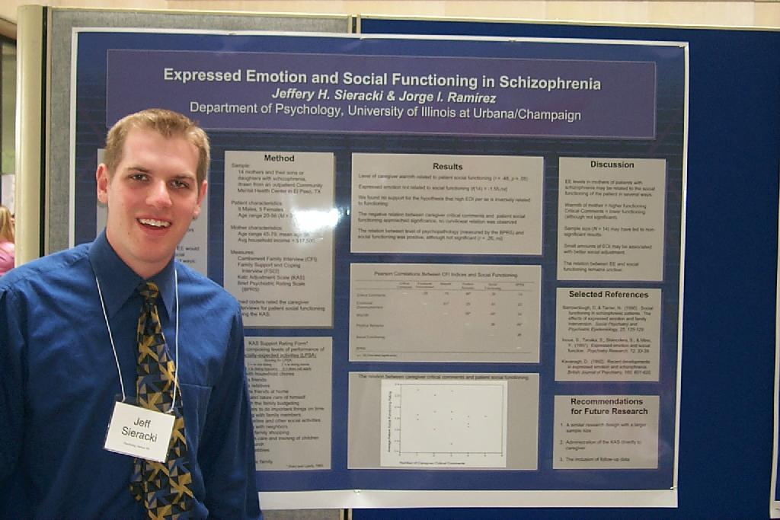
III. Author a Psychology MAGAZINE and Presentation: Research, publish, and present your own comprehensive Psychology Magazine. It should contain articles, advertising, puzzles, cartoons, and advice columns (similar to magazines that you might buy). In addition to expressing your writing and creative abilities, your magazine should demonstrate what you’ve learned (and/or further research you’ve done). For example, an advice column should reflect ideas that you have learned about behavior in this course. Your project must include the following:
- An Original Title and Magazine Style Cover
- A complete Table Of Contents including credits
- Editorials on psychological based news (1+ articles): State your opinion about actual psychology news. News articles may be found online and in psychology magazines.
- News / trends (1+ articles): Report on interesting news articles that you read.
- Original (Research-Based) Articles (1+ per group member): Original articles should be at least two double-spaced, typed pages in length. Articles must be research-based concerning a concept covered by Psychology. You may choose a topic that you will research, or conduct your own experiment or survey. While the experiments/surveys must be scientific, you do not need an entire write-up (as in Part II above). Include at the end, a short paragraph on your personal view concerning the topic. You must show knowledge through research of content in your personal reflections. E.g. “How to Raise an Honest Child”, or “Identify Achievement in 5 Easy Steps”, or “You Too Can Sleep Well”. I highly recommend choosing a topic that affects you personally.
- Journal Article Reviews (1+ per group member): Articles reviewed must be major articles with a psychological theme. They may be from any major magazine or journal published within the last 4 years. The articles must be copied and attached to the annotated bibliography. The review itself should be at least one typed page in length emphasizing the psychological aspects of the article
- Book or Movie Reviews (1+ per 2 group members): The review must open with the bibliographical data (author, date, publisher, director, producer, etc.) The movie or book must have a strong psychological them: and your review must emphasize the psychological validity or accuracy of the content. These reviews should be at least one typed page. Remember to rate the movie!
- Health / Pharmacology report (1+ articles)
- Technology / computer column (1+ articles)
- Advice column (2+ responses)
- Classifieds (1+ pages)
- Advertisements (2+ ads per group member): You may use an existing product/service or you may create a product/service of your own. Either way, your ad must be original.
- Misc. items: comics, puzzles, games (1+ pages)
- An Annotated APA Works Cited of all sources used by all group members
In addition, please note the following:
- Submit all content to turnitin.com (see AP Psych Final Project link on my website)
- All contributions to the magazine must reflect psychological content.
- All formatting should appear uniform (i.e. in the same legible typed font, paragraph formats…). Include many pictures throughout!
- During your presentation discuss ONLY 3-5 articles in detail.

